# Product Realization (A8024)

**IT -C** Team No.

**11**

**Prevention of fire in electric vehicles**

Abstract**:**

**Electric cars, or EVs, have completely changed the global car industry because of the**

**explosive advancements in lithium-ion batteries over the last ten years. However,**

**the possibility of fires brought on by extremely potent batteries is a significant safety**

**worry for EVs. The recent Electric fire safety problems, like heat runaway and battery**

**life fires, are the main topic of this review. Thermal runaways, flames, explosions,**

**and the release of poisonous fumes can result from extreme abuse, such as equipment**

**failure or accidents. The paper presents an unbiased evaluation of the combustion risks**

**associated with bus, hybrid, and electric batteries, emphasizing important test**

**derived fire characteristics. The Peak rate of heat release (PHHR) is influenced by**

**the electrical ability of Li-ion batteries, suggesting that the fire risks associated with**

**electric cars (EVs) are similar to those of cars powered by gasoline.**

**KEYWORDS: Battery management system, Thermal runaway, Battery cooling technology.**

**Team Members:**

**P.Vineesh -(H0)**

**P.Deepak teja-(H2)**

**P.Varsha Sree-(H3)**

**R.Ajay Kumar-(H4)**

**R.Jyothirmai -(H5)**

**U.Shyam Sudar-(J 5)**

# Product Realization (A8024)

**Product Details**

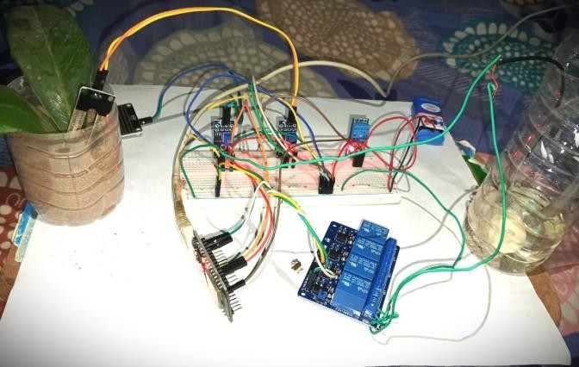

# Need Statement:

Preventing vehicle fires is essential for ensuring passenger safety, protecting property, and preserving the environment. Key measures include regular maintenance of electrical, fuel, and exhaust systems; proper handling and storage of flammable materials; maintaining electrical system integrity; ensuring fuel system integrity; and maintaining the exhaust system. Additionally, raising awareness and providing training on fire risks and emergency response are crucial. Equipping vehicles with fire extinguishers and training drivers on their use further enhance safety. Implementing these practices significantly reduces the risk of vehicle fires, promoting overall safety.

**Community Partner Feedback and a Pic with community partner:**

• **Local Fire Departments**: They provide expertise on fire safety and can offer training and resources for fire prevention.

• **Automobile Manufacturers**: Companies like Ford, General Motors, Tesla, and others can collaborate to ensure their vehicles meet high safety standards and educate consumers.

• **Automobile Dealerships**: Local dealerships can play a role in educating new car buyers on fire prevention and safety measures.

.

# Cost Analysis:

This is a primary structure. The target market, production techniques, and system technologies' level of complexity will all affect the project's final costs.

# Picture of Product:

Fig: The working model of sensor-fusion system

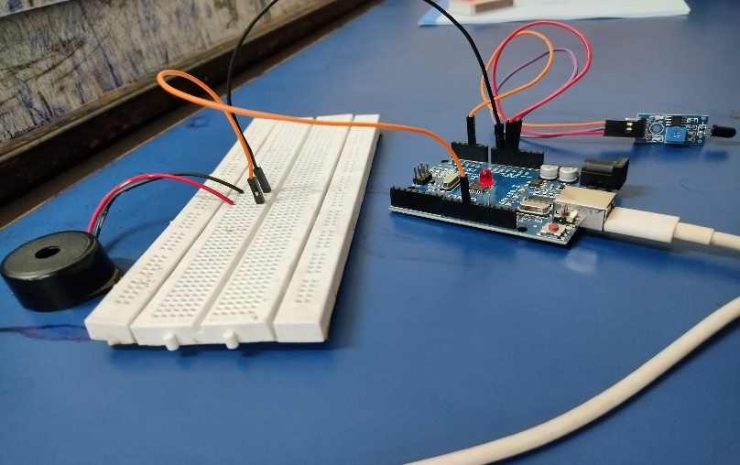

**Faculty Mentor: Rajitha Ala**

**Assistant Professor**